***Result on Simulated and Observed flow value at Outlet-1 for Green and Ampt Loss Method.***

**RUN-1: Green and Ampt, Salt Lake Traid, Daily Time-Step (01/10/2010-30/09/2011),, (GHCN)**

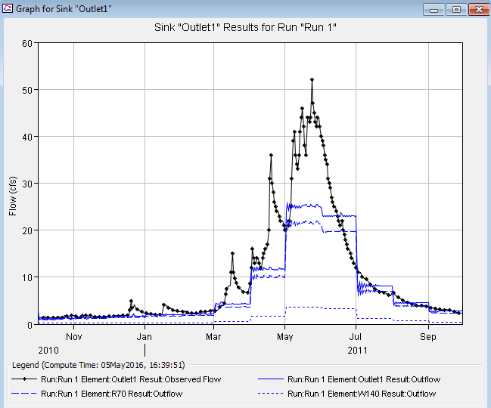

*Fig-H1:**Result on Simulated and Observed flow value at Outlet-1*

**RUN-2: Green and Ampt, Three precipitation Stations (ARBR_C, TM_C, and KF_C) based on elevation, Daily Time-Step (01/01/2015-31/12/2015), (iUtah)**

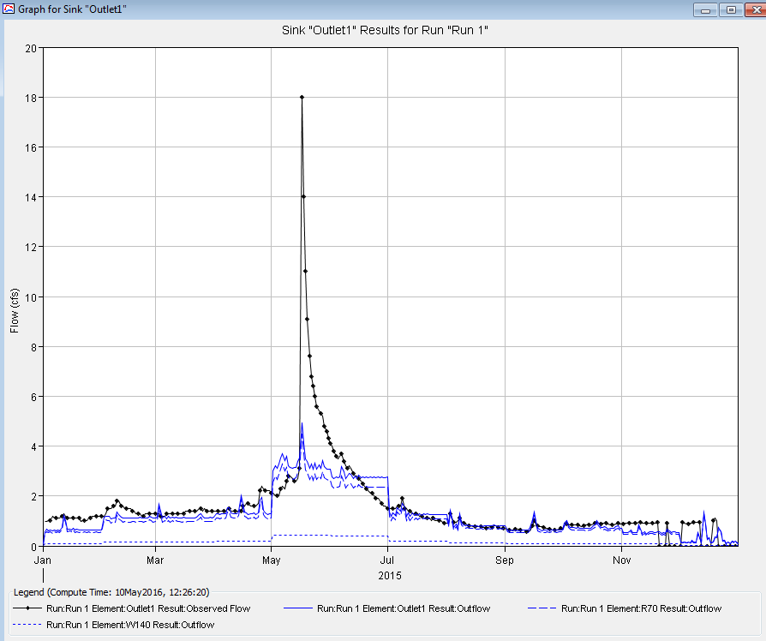

*Fig-H2**Result on Simulated and Observed flow value at Outlet-1*

**RUN-3: Green And Ampt, GIRF, Daily Time-Step (01/01/2015-31/12/2015), (Iutah)**

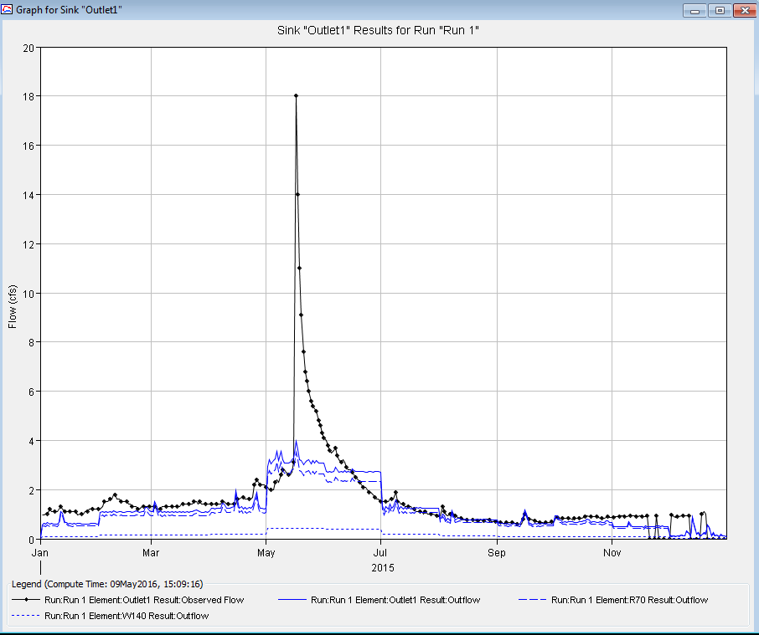

*Fig-H3*:*Result on Simulated and Observed flow value at Outlet-1*

**RUN-4: Green and Ampt, ARBR_C, Daily Time-Step (01/01/2015-31/12/2015), (Iutah)**

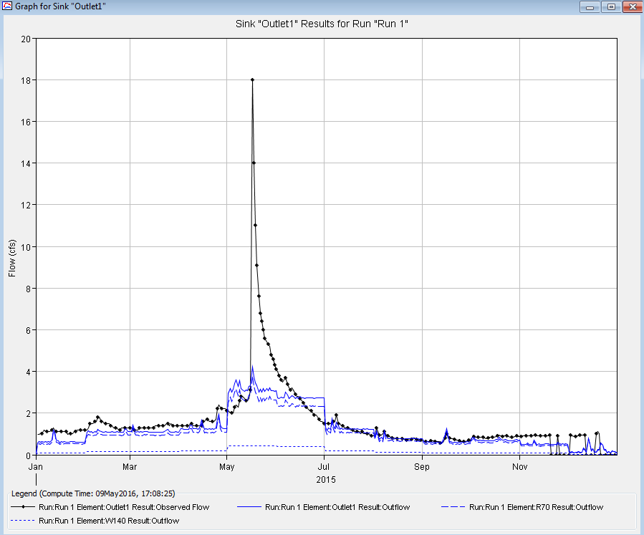

*Fig-H4:**Result on Simulated and Observed flow value at Outlet-1*

**RUN-5 Green and Ampt, TM_C, Daily Time-Step (01/01/2015-31/12/2015), (iUtah)**

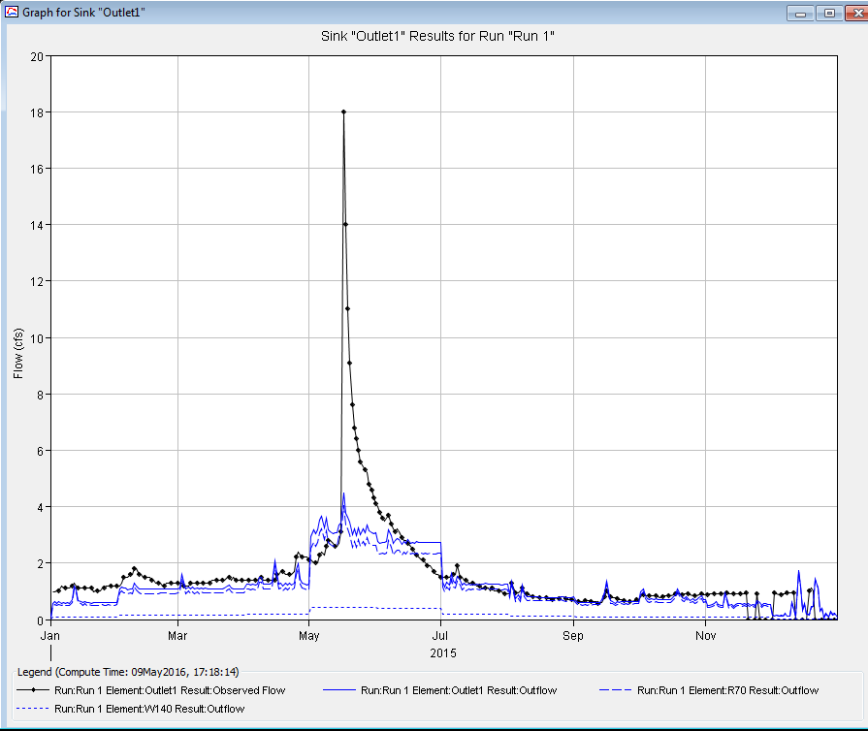

*Fig-H5:**Result on Simulated and Observed flow value at Outlet-1*

**RUN-6: Green and Ampt, KF_C, Daily Time-Step (01/01/2015-31/12/2015), (iUtah)**

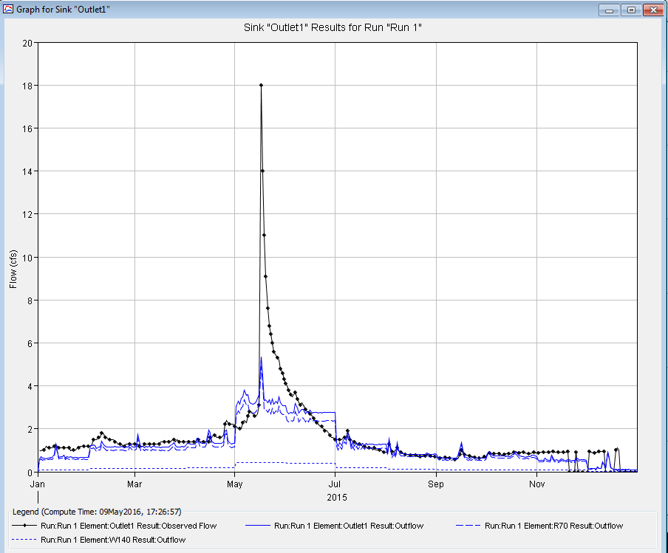

*Fig-H6:**Result on Simulated and Observed flow value at Outlet-1*

**RUN-7: Green and Ampt, KF_C, 15min Time-Step (01/01/2015-31/12/2015), (iUtah)**

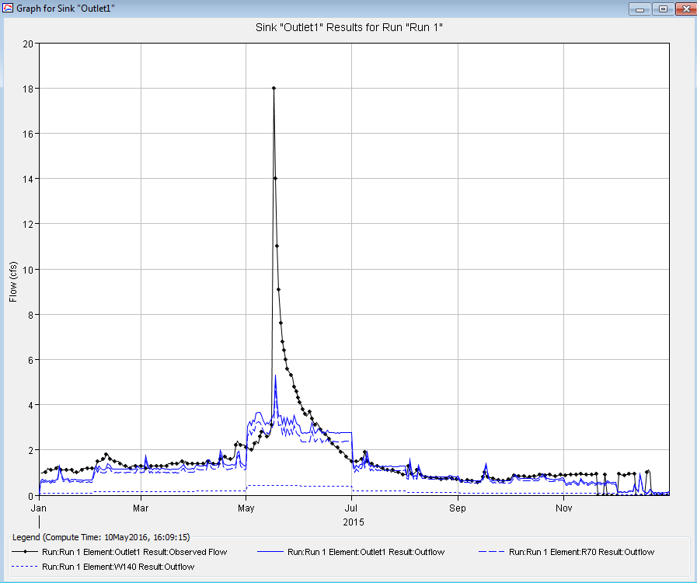

*Fig-H7:**Result on Simulated and Observed flow value at Outlet-1*

**RUN-8: Green and Ampt, KF_C, Daily Time-Step (01/01/2015-31/12/2015), Without Base-flow, (iUtah)**

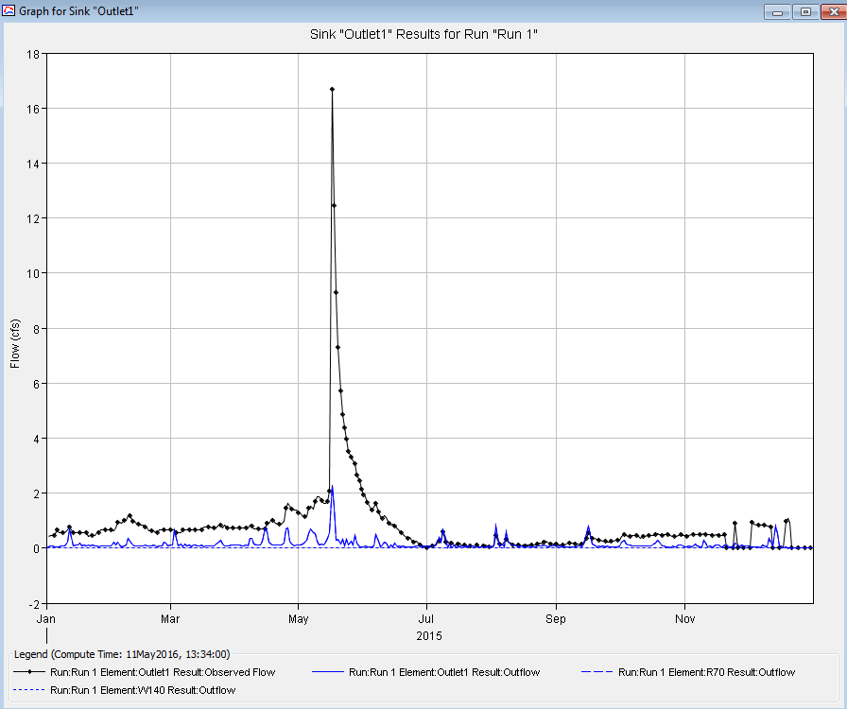

*Fig-H8:**Result on Simulated and Observed flow value at Outlet-1*

***Result on Simulated and Observed flow value at Outlet-1 for SCS Loss Method.***

**RUN-9: SCS, GIRF, Daily Time-Step (01/01/2015-31/12/2015), (Iutah)**

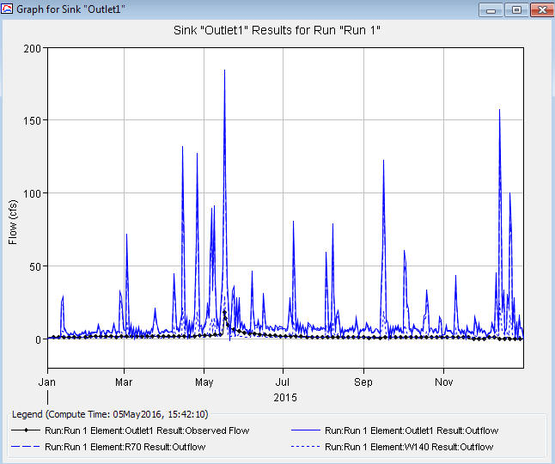

*Fig-H9:**Result on Simulated and Observed flow value at Outlet-1*

**RUN-10: SCS, ARBR_C, Daily Time-Step (01/01/2015-31/12/2015), (Iutah)**

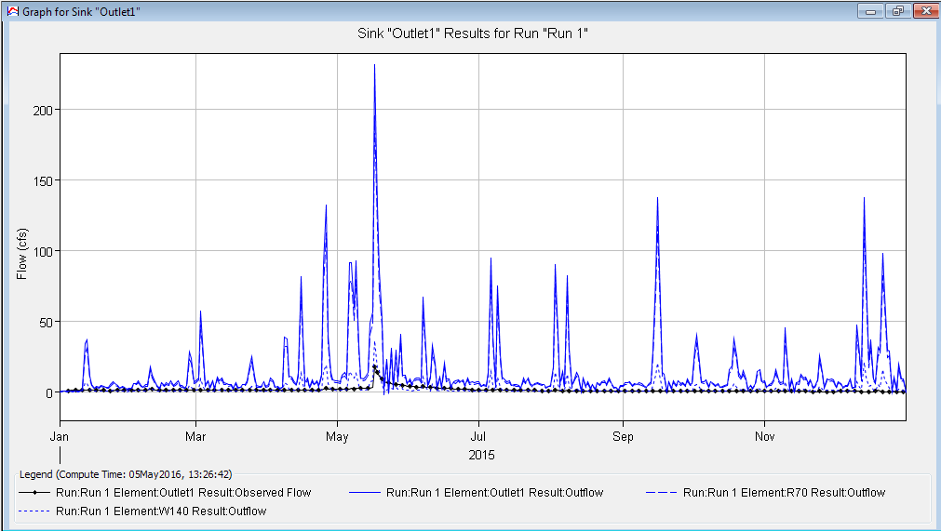

*Fig-H10:**Result on Simulated and Observed flow value at Outlet-1*

**RUN-11: SCS, TM_C, Daily Time-Step (01/01/2015-31/12/2015), (Iutah)**

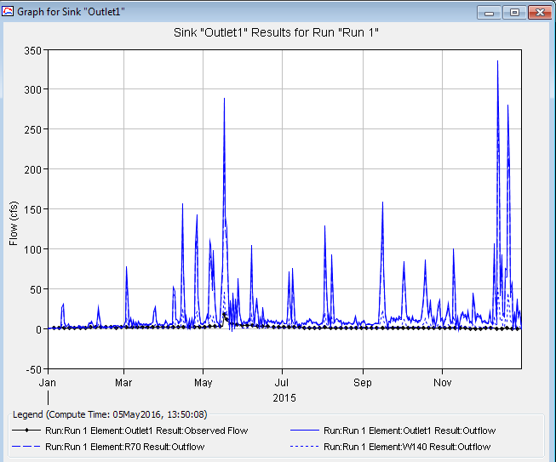

*Fig-H11:**Result on Simulated and Observed flow value at Outlet-1*

**RUN-12: SCS, KF_C, Daily Time-Step (01/01/2015-31/12/2015), (Iutah)**

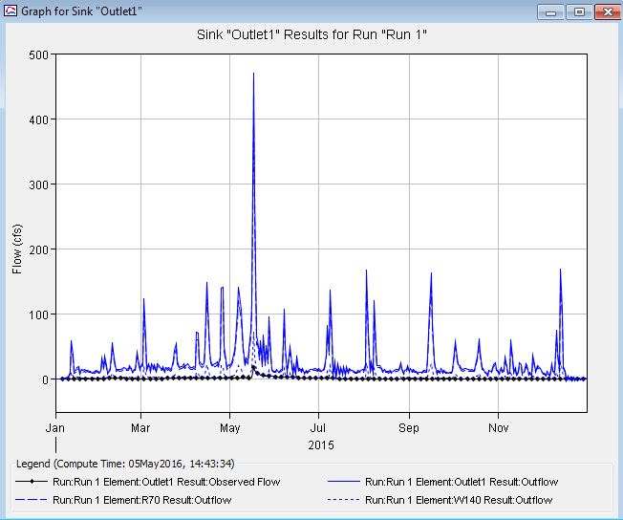

*Fig-H12:**Result on Simulated and Observed flow value at Outlet-1*

**RUN-13) SCS, Salt Lake Traid, Daily Time-Step (01/10/2010-30/09/2011), (GHCN)**

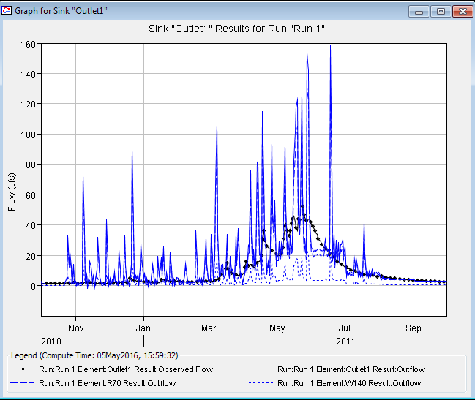

*Fig-H13:**Result on Simulated and Observed flow value at Outlet-1*

**RUN-14: SCS_Salt Lake Traid, Daily Time-Step (01/10/2010-30/09/2011), without Base-flow, (GHCN)**

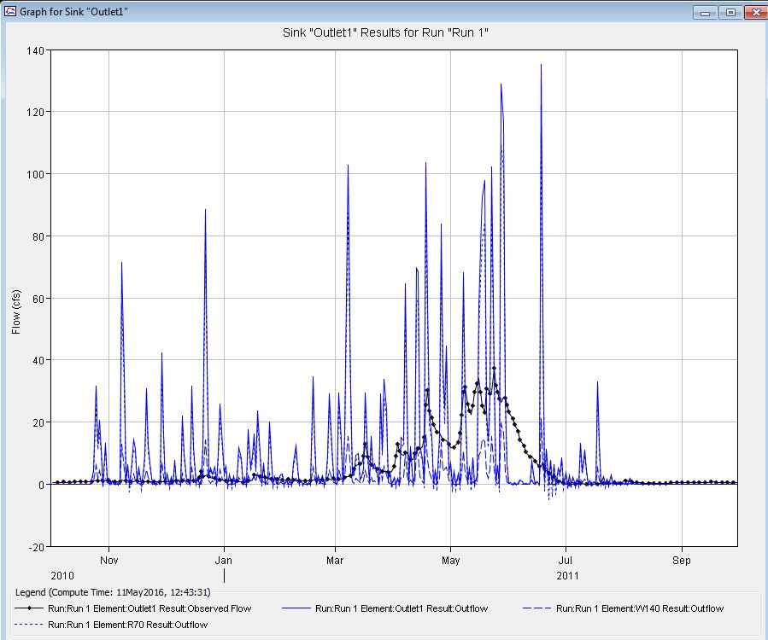

*Fig-H14:**Result on Simulated and Observed flow value at Outlet-1*